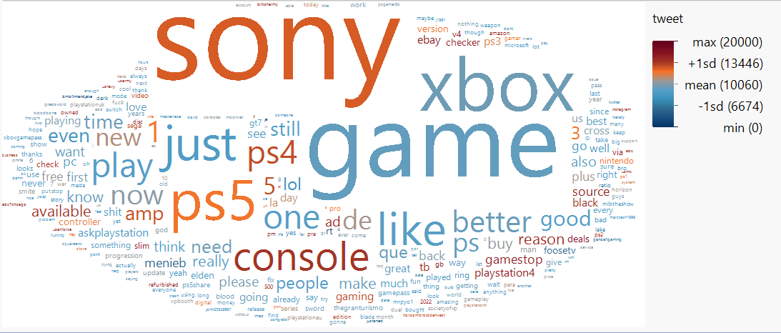JMP software is a great tool we learned in text mining that is used for designed experiments and analyzing statistical data from industrial processes. This tool is very good statistical tool in it features and functionalities. So, I used this software to run a sentiment analysis based on the tweets PlayStation file. Using this tool, I obtained a word cloud based on the top count words from this dataset. Then, I continued to color coded based on the influence of the tweets.

Figure 1: Word Cloud

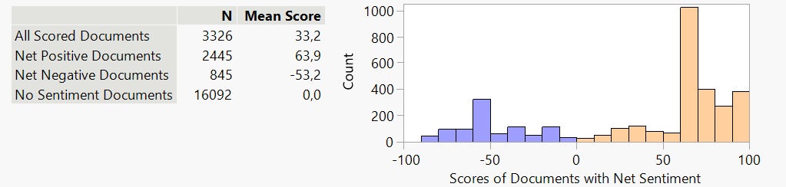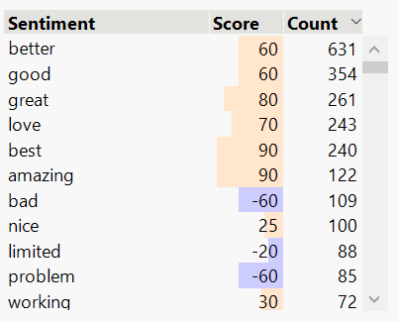Then I continued to run a sentiment analysis using the tweets, as we wanted to dig deeper on the customer’s opinion of PlayStation and their overall experience with them. Good thing with this software, we can see a list of all the words included in the sentiment analysis and see if they are positive or negative. Based from the list on the right, you can see that from the top 10 words the majority are positive and they are only 3 bad words. You can also see the scores of each of the words at how good or bad they are based on the score. 90/-90 being the maximum. Also, if you click the word best for example, a bunch of tweets with the word best shows up. Some interesting ones are customers talking about how play station has the best games. In the last visualization on the bottom, you see the overall scores and a histogram with the distribution. From it you can conclude, that play station’s customers has on overall a more positive experience.

Figure 3: sentiment analisis summary

Figure 2: table of sentiment words